**Understanding Potentiometers:**

# **How a Potentiometer Works**

A potentiometer also referred to as pot may come in a wide variety of shapes and are used in many applications in your daily life, for example to control the audio volume of the radio.

A pot is a manually adjustable variable resistor with three terminals. In the figure below you can see some examples of potentiometers.

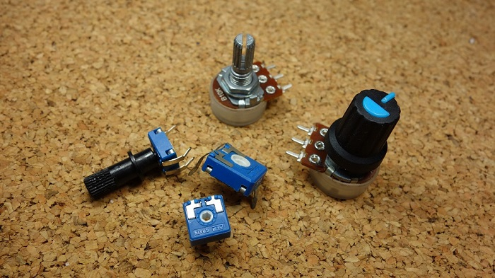

## **Potentiometer Symbols**

In a circuit diagram, a [potentiometer](https://makeradvisor.com/tools/potentiometer-assortment-kit/) is represented by one of the two symbols below:

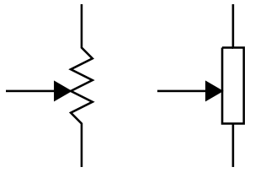

## **How Does a Potentiometer Work?**

A potentiometer has 3 pins. Two terminals (the blue and green) are connected to a resistive element and the third terminal (the black one) is connected to an adjustable wiper.

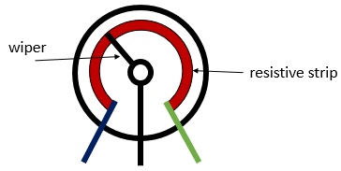

## **Rheostat(variable resister):**

To use the potentiometer as a rheostat, only two pins are used: one outside pin and the center pin. The position of the wiper determines how much resistance the potentiometer is imposing to the circuit, as the figure demonstrates:

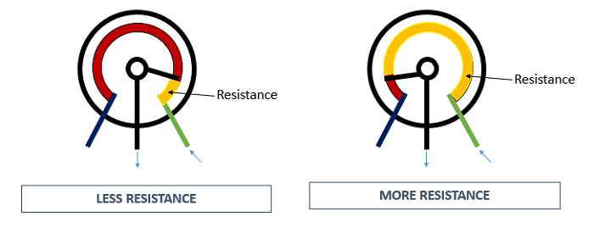

If we have a 10kΩ potentiometer, it means that the maximum resistance of the variable resistor is 10kΩ and the minimum is 0Ω. This means that by changing the wiper position, you get a value between 0Ω and 10kΩ.

## **Voltage Divider**

Potentiometers can be used as voltage dividers. To use the potentiometer as a voltage divider, all the three pins are connected. One of the outer pins is connected to the GND, the other to Vcc and the middle pin is the voltage output.

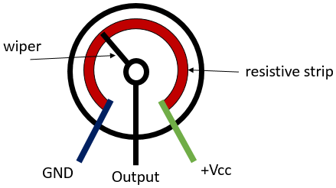

When the potentiometer is used as a voltage divider, the wiper position determines the output voltage. When you have the potentiometer connected this way, you have the following circuit:

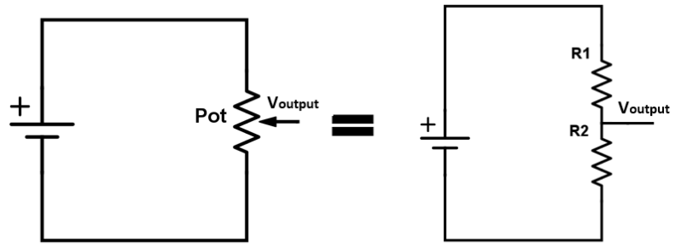

Basically, the voltage divider is used to turn a large voltage into a smaller one.

The output voltage can be calculated using the following equation obtained from Ohm’s Law:

